OUTPUT PROGRAM :
- CELL 1 & 2
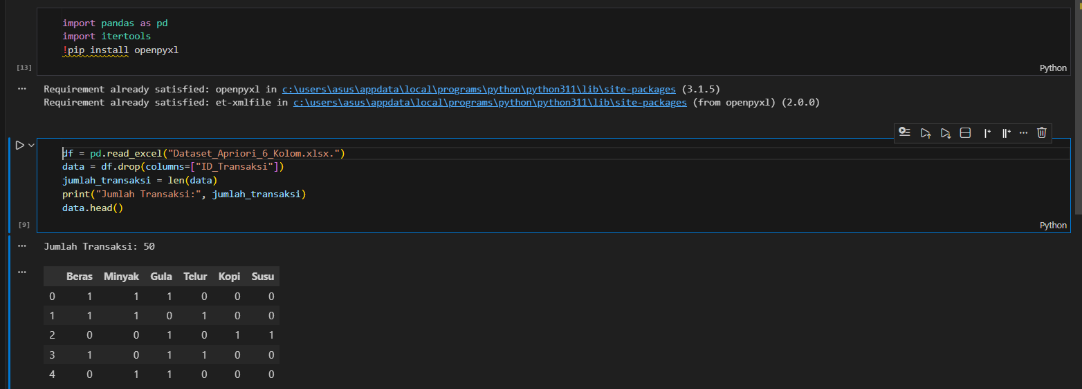
- CELL 3 & 4
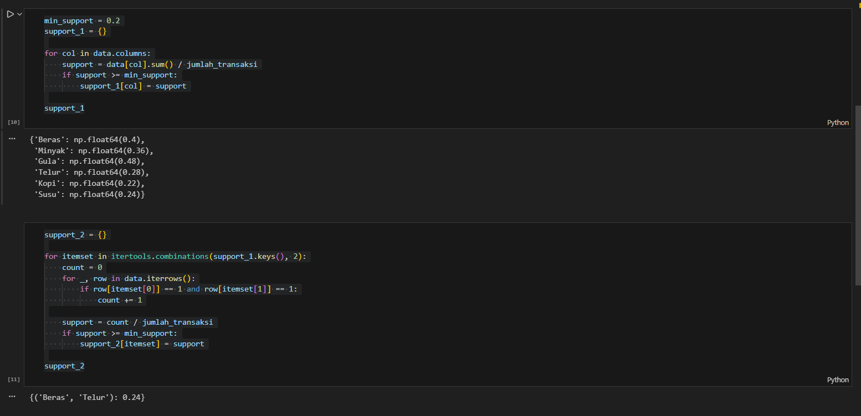
- CELL 5
